NDITHRIVE CLIENT WELCOME PACK
Welcome to NDIThrive Pty Ltd.
We are thrilled you have reached out to join us.
Read through the information provided on what we offer and give us a call if you have any further questions.
At NDIThrive, we are a compassionate partner in nurturing and developing your independence, growth, and wellbeing. It's what our name stands for.
Our mission is rooted in the belief that every individual deserves personalised care, enabling them to truly THRIVE. Whether you're seeking a nurturing space for personal growth, in-home supports or a meaningful, engaging program on a real working farm, NDI Thrive is here to support you every step of the way.

Our Day Programs are available for ages 5 – Adult on the NDIS

*** At the end of this form – there are links to our NDIS Intake and NDIS Service Agreement Forms for you to fill out. They are all able to be done online (no printing or scanning)

Our Disability Supports offer personalised care that are tailored in design to meet the unique needs and goals of each participant.

NDIThrive offers supports including;
​Individual Support
Support Coordination
Counselling
Therapies
Workshops
Community Access
Farm Day Programs (Kids and Adults)
Equine Assisted Learning (EAL)
We also run wellness programs including Yoga, Meditation and Sound Healing
​​
Together, let's cultivate a future full of independence and infinite possibilities.

Our Values
Empowerment | Compassion | Personalized Care | Connection
Integrity | Wellbeing | Innovation | Resilience | Collaboration
Independence

WHAT WE OFFER
FARM DAY PROGRAMS
NDIThrive Program Outline

Location: 231 Bangholme Road, Bangholme VIC 3175
Schedule: Monday’s Kids 5-13 and Tuesday to Friday: Adults
Program Duration: 10am-3pm (June/July/August) 9am-4pm (Sept-May)
Participants: Participants on the NDIS
Funding: 01 and 04 Core line items. We can also use CB Daily Activity should the stated support include programs like ours.
Costs: Are determined based on the individual client attending. Costs are outlined in our Fee Schedule in this Welcome Pack.

Farm Daily Program Structure

10.00 AM: Arrival and Registration

Participants arrive, check-in, and handover to Support Workers/ Facilitators for the day.

Required: Please ensure that a morning and afternoon tea snack and lunch is provided if participating in Woodwork or Creative Arts.

Provided: Farm Day Programs NDIThrive provide Morning/Afternoon Tea, and Lunch.

Please bring any personal water bottles, however water bottles will also be available.
Some Days will be In-House. Most in-house days will be weather determined. (See below alternate program).
Our Farm offers a diverse range of activities such as Animal Husbandry, Garden and Horticulture, Cooking, Crafting and Fresh Air. There is much to do on our Farm and no two days are the same however we believe in allowing people to breath, relax and connect with their surroundings also. Clients engage and regulate through nature based activities and our holistic approach to connection with land and self, we have found helps center and regulate emotional disengagement.

Learning Outcomes: Self-Awareness and Self-Advocacy | Resilience Building | Personalized Goal Setting | Community Engagement and Social Connection | Emotional Regulation and Wellbeing | Empowered Decision-Making | Independence and Self-Sufficiency | Adaptability and Growth Mindset | Collaborative Teamwork

Lunch Breaks
WORKSHOPS: Participants stop to enjoy a communal lunch break with lunch they have provided
FARM DAY PROGRAMS: Participants source ingredients from the farm or provided by NDIThrive and with guided assistance, prepare a nutritional lunch which is then enjoyed communally.
Examples of lunches day programs might be cooking using ingredients grown from the farm to make pizza’s, taco’s or zucchini slice for example. We love using our own eggs to make cakes, scones, quiche’s and omelettes. NDIThrive Staff hold Food Handling Certificates. We also have EPIPENS for Adults and Children and stay aware of provided information regarding Allergies and Intolerances.

3:00 PM: Program Conclusion and Departure (Sept-May 4pm Conclusion)

Participants prepare to leave.

Staff provide feedback and discuss the day's achievements with participants and caregivers.

IN-HOUSE PROGRAM (FOR WET or HOT WEATHER DAYS):
Overview:
On wet or extremely hot weather days, in-house programs in our Art Centre offer a fun and relaxing environment where individuals can explore their creativity through hands-on projects and enjoy games. These activities are designed to foster self-expression, relaxation, and social connection.

1. Creative Project Activities
- Collages
  - Activity: Participants create collages reflecting their interests, emotions, or imaginative designs.
  - Goal: Encourage creativity and self-expression.
- Painting
  - Activity: Individuals paint free-form art and group pieces, themed pieces, or explore new painting techniques.
  - Goal: Promote creativity, relaxation, and visual communication in a group.

- Crafting
  - Activity: Crafting projects like jewelry, cards, or decorations using nature such as pinecones, tree bark and rocks.
  - Goal: Develop fine motor skills and artistic creativity.
- ClayWorks/Pottery
  - Activity: Individuals explore clay and how to mould and shape making unique pieces. We may use the Pottery Wheels however we don’t do large pieces. Clients are able to prepare and fire (Staff to use Kilns) smaller pieces. Pottery may not be offered every day.
  - Goal: Promote creativity, relaxation, and visual communication in a group while exploring the medium of clay.

- Stenciling
  - Activity: Use stencils to create patterns on canvas.
  - Goal: Encourage precision and fine motor skills.

2. Games & Group Activities
- Board Games
  - Materials: A variety of board games.
  - Activity: Play fun and interactive games that encourage teamwork or friendly competition.
  - Goal: Foster socialization, strategic thinking, and relaxation.
- Puzzle Challenges
  - Materials: Jigsaw puzzles, brainteasers.
  - Activity: Work individually or in teams to complete puzzles or solve challenges.
  - Goal: Enhance problem-solving skills and teamwork.

- Indoor Scavenger Hunt
  - Materials: A list of items to find, small rewards.
  - Activity: A fun search for hidden items around the indoor space.
  - Goal: Develop observation skills and teamwork.

HOMESCHOOLING
🌱 Welcome to Our Homeschool Program
At NDIThrive, we are proud to offer a personalised Homeschool Program designed specifically for children supported through the NDIS. Our program recognises that every child learns differently, and we tailor our approach to suit each individual’s learning style, pace, and goals.
Our curriculum is built around the NDIS Core Supports, ensuring we meet key developmental areas such as:
- Daily Living Skills
- Social and Communication Development
- Emotional Regulation
- Literacy and Numeracy Foundations
- Motor Skills and Sensory Integration
Through a blend of hands-on learning, creative expression, and structured routine, we create a safe, engaging, and supportive environment where children thrive. Whether your child is a visual learner, hands-on explorer, or benefits from movement and outdoor experiences, we adjust our sessions to best support their unique way of engaging with the world.
Our program is delivered in small groups or one-on-one settings and includes regular updates and goal reviews in collaboration with families, therapists, and support coordinators.
We’re so glad to have you with us, and we look forward to supporting your child’s journey.


INDIVIDUAL SUPPORTS

Individual NDIS Supports at NDIThrive
At NDIThrive, we are dedicated to providing personalised NDIS support that empowers individuals to achieve their goals and enhance their quality of life. Our approach focuses on a holistic, person-centered model of care, offering tailored services that address the unique needs and aspirations of each participant.

Key Features of Our Individual NDIS Support:
- Personalised Care Plans: We work closely with participants to develop individualised support plans that are focused on achieving specific goals, whether it’s improving communication, increasing independence, or enhancing social participation.

- Skill Development: Our support services focus on building important life skills, including communication, personal care, social interactions, and decision-making. We offer programs in areas such as creative arts, community engagement, and daily living skills.
- Assistance with Daily Activities: We provide hands-on support for daily tasks, including personal care, household chores, and managing appointments, helping participants maintain their independence and lead fulfilling lives.
- Capacity Building: Through tailored activities and interventions, we help individuals build skills for long-term independence, such as financial management, travel training, and accessing community resources.
- Community and Social Participation: We encourage individuals to engage with their local communities through social, recreational, and educational activities, fostering greater social inclusion and community connection.
At NDIThrive, our goal is to support each individual in reaching their full potential by providing the care, guidance, and resources needed to thrive in all aspects of life.


SUPPORT COORDINATION

Support Coordination at NDIThrive
At NDIThrive, our Support Coordination services are designed to empower NDIS participants by helping them navigate and maximize the supports available to them. Our experienced Support Coordinators work closely with individuals to ensure they can effectively access and manage the services and resources they need to achieve their goals.
Key Features of Our Support Coordination:
- Tailored Support Plans: We collaborate with participants to understand their unique needs and aspirations, creating customized support plans that align with their individual goals and preferences.
- Connecting with Providers: Our Support Coordinators assist participants in finding and connecting with suitable service providers, ensuring they receive the right services for their specific needs, whether it’s therapy, personal care, or community access.

- NDIS Plan Implementation: We help participants implement their NDIS plan by ensuring that all supports and services are coordinated and aligned with their goals, providing clear guidance and support throughout the process.
- Coordination of Services: We coordinate between different service providers, ensuring that all aspects of care are well-managed, reducing any gaps or overlaps in support. This includes organising appointments, arranging transport, and managing schedules.
- Advocacy and Problem-Solving: Our Support Coordinators advocate on behalf of participants, helping them resolve issues with service providers or navigating challenges within the NDIS system to ensure they get the most out of their plan.
- Building Independence: We work with participants to build skills and confidence in managing their supports, with the goal of fostering greater independence in accessing services, managing budgets, and making informed decisions about their care.
- Goal Achievement: We continuously review progress with participants, ensuring that the supports in place are helping them achieve their goals. If needed, we adjust the support plan to better align with evolving needs and aspirations.
At NDIThrive, we are committed to ensuring that our Support Coordination services help participants navigate the NDIS system smoothly, access the best possible supports, and achieve meaningful outcomes. We empower individuals to take control of their journey, building the confidence and skills to live a fulfilling and independent life.

COUNSELLING


Personalised Support: Your goals and preferences are our priority, and we tailor our services to meet your individual needs.
Experienced Team: Our compassionate staff brings a wealth of expertise and a genuine desire to make a positive difference in your life.
Collaborative Care: We work closely with you, your family, and other service providers to ensure seamless and effective support.
At NDIThrive Pty Ltd, we believe that everyone deserves the opportunity to live a fulfilling life. Together, we’ll help you achieve your goals and reach new heights of independence and well-being.
Let’s Thrive Together!

SYNERGY PLAY THERAPY

Synergy Play Therapy at NDIThrive
At NDIThrive, we offer Synergy Play Therapy, a therapeutic approach designed to support children and individuals (even adults!) in overcoming emotional, behavioral, and developmental challenges through the power of play. Our Play Therapy services are grounded in creating a safe, nurturing environment where participants can express themselves, process emotions, and build coping skills in a creative and engaging way.
Key Features of Synergy Play Therapy:
- Individualised Therapy Sessions: Our Play Therapist provides one-on-one sessions tailored to each participant’s unique needs, using a variety of play-based techniques to address emotional, social, and psychological challenges.
- Emotional Expression and Processing: Play therapy allows participants to express and explore their feelings in a non-threatening, enjoyable way. Through activities like role-play, storytelling, and art, children and individuals can process emotions they may struggle to verbalize.

- Building Social and Communication Skills: Play Therapy fosters the development of important social skills, such as sharing, turn-taking, and communication. It also provides a supportive environment for participants to build self-esteem and improve relationships with others.
- Behavioral Support and Development: Our therapy approach helps participants understand and manage their behaviors, with a focus on building positive coping strategies and emotional regulation skills.
- Trauma-Informed Care: For individuals who have experienced trauma or challenging life experiences, Synergy Play Therapy provides a gentle, supportive space for healing. Therapeutic play can help children and individuals process past experiences and work through fears, anxiety, or grief.
- Goal-Oriented Progress: We work collaboratively with families and other support teams to set achievable goals and track progress. The therapeutic activities are designed to build skills and create lasting positive changes in emotional and social development.
- Holistic Approach: Synergy Play Therapy integrates different therapeutic techniques, including expressive arts, sensory activities, and games, to support the mental, emotional, and physical well-being of each participant.
- Family Involvement and Support: We encourage family members to be involved in the therapeutic process, providing guidance on how to support their loved one’s growth and development at home.
At NDIThrive, Synergy Play Therapy helps individuals build resilience, emotional intelligence, and the skills needed to navigate challenges. Our goal is to provide a nurturing, therapeutic environment where individuals can thrive emotionally, socially, and behaviorally, ultimately empowering them to lead more fulfilling lives.

THE MIND BODY & SOUL EXPERIENCE
The Mind, Body and Soul Experience
Our newest holistic wellbeing program at NDIThrive
This unique experience is designed to guide participants through a journey of self-awareness, emotional regulation, and inner balance. Delivered in three gentle and engaging parts, this program supports participants in understanding how their mind, body, and soul work together to promote wellbeing.
🧠 Mind
Led by our qualified Synergy Play Therapist Mel, this session focuses on understanding how the mind responds to stress and anxiety. Participants will explore tools and strategies to recognise their emotional state and learn effective techniques to regulate thoughts and feelings, particularly in moments of overwhelm. (1hr = $193.99 + $2.59 (Centre Capital Cost) + $17.55 report writing) = $214.13)
💪 Body
When the mind is stressed, the body follows. In this Spiritual PT Session, participants will learn how stress impacts the physical body and will be guided through body-based practices to release tension, restore calm, and build awareness of their physical responses to emotional triggers. (1hr = $70.23 + $2.59 + $17.55 = $90.37)
🌀 Soul
The final session explores the connection to the self – the soul. Participants will be gently introduced to practices that help them tune into their inner world, understand what their soul needs, and how working in harmony with this awareness can support emotional resilience and deep inner calm. Using Tibetan and Crystal Singing bowls, Meditation, Shamanic Drumming and Guidance. (1hr = $70.23 +$2.59 +$17.55 = $90.37)

WORKSHOPS
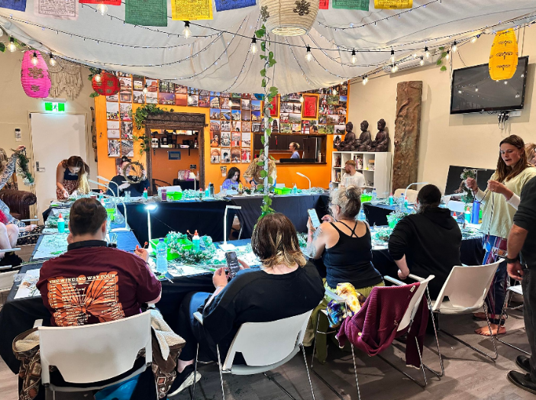
Workshops are a wonderful way of achieving positive learning outcomes and meeting goals within an NDIS Plan or Homeschool Curriculum. They are also SO MUCH FUN!
Learning Outcomes for Creative Arts (Aligned with NDIS Goals)
- Developing Effective Communication:
  - Enhancing verbal and non-verbal communication skills through sharing ideas, explaining creative choices, and discussing artwork with others.
  - Building confidence in expressing thoughts and emotions through visual arts and group discussions.

- Developing Social and Community Participation.
  - Foster collaboration and teamwork in group art projects, improving social interaction and participation in a community setting.
  - Encouraging connection and shared creativity, leading to stronger bonds and support within the group.
- Developing Independence.
  - Promoting decision-making skills and self-reliance by guiding participants through the creative process and encouraging independent project completion.
  - Supporting participants in setting personal goals for their artwork and achieving them with minimal assistance.
- Improving Mental and Emotional Well-being.
  - Providing an outlet for emotional expression and self-reflection through creative projects, contributing to improved emotional regulation and resilience.
  - Encouraging a sense of accomplishment and satisfaction by completing art projects, boosting self-esteem and confidence.
- Enhancing Motor Skills and Physical Independence:
  - Strengthening fine and gross motor skills through hands-on art activities like sculpting, painting, and beading.
  - Developing spatial awareness and coordination through activities that require precision and movement.
- Building Confidence in Social Settings.
  - Creating opportunities for participants to present their artwork, helping them develop confidence in public speaking and sharing their achievements.
  - Fostering social skills in group settings through art-based interactions and feedback sharing.
These learning outcomes connect creative arts activities to the broader NDIS goals, supporting personal growth, communication, social participation, and independence.

CHECK OUT OUR CURRENT WORKSHOPS

WOODWORKING

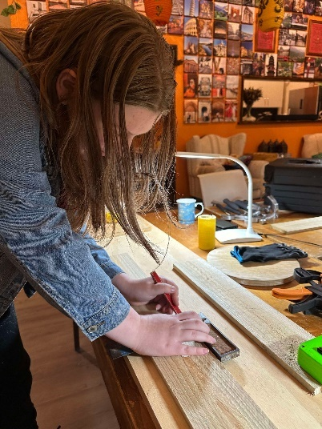

2:00 PM - 4:00 PM: Woodwork – Friday’s Weekly (All Ages)

Activity: Guided woodworking projects such as building birdhouses, toolboxes, Jewellery, or crafting decorative items. Programs are individualized for participant.

Learning Outcomes: Developing craftsmanship, understanding tool safety, creative expression.

Individualised Goals: Improve hand-eye coordination, foster creativity, enhance problem-solving skills.

CREATIVE ARTS
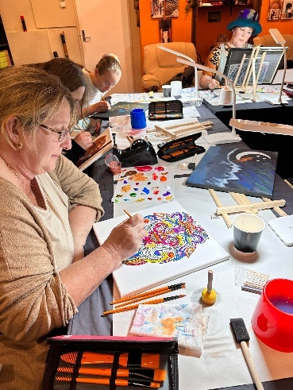

1.00pm – 4.00 PM – Creative Arts – Sundays Weekly (All Ages)

Activity: Guided Creative Arts such as Stenciing, Painting, Mosaicking with various mediums.
Description:

Learning Outcomes: • Creativity and Self-Expression| Fine Motor Skills Development | Problem-Solving and Critical Thinking | Patience and Focus | Collaboration and Social Skills | Attention to Detail | Confidence and Sense of Accomplishment | Cultural and Artistic Awareness | Emotional Regulation and Stress Relief | Innovation and Experimentation

Individualised Goals: Develop creativity and personal expression | Improve fine motor skills and hand-eye coordination | Enhance problem-solving and decision-making abilities | Build patience and focus through detailed work | Increase confidence through completing creative projects

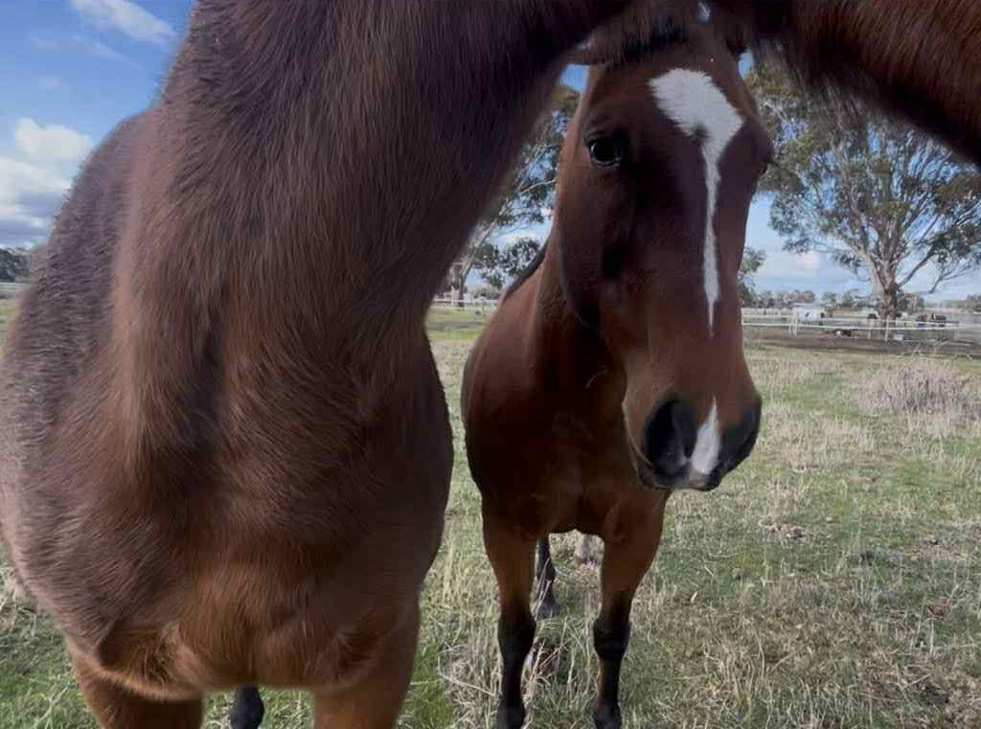
🌿 Equine Assisted Learning (EAL) Program for NDIS Participants (All Ages from 5)
Offered Every Sunday – Hourly Sessions (10am, 11am, 12pm, 1pm)
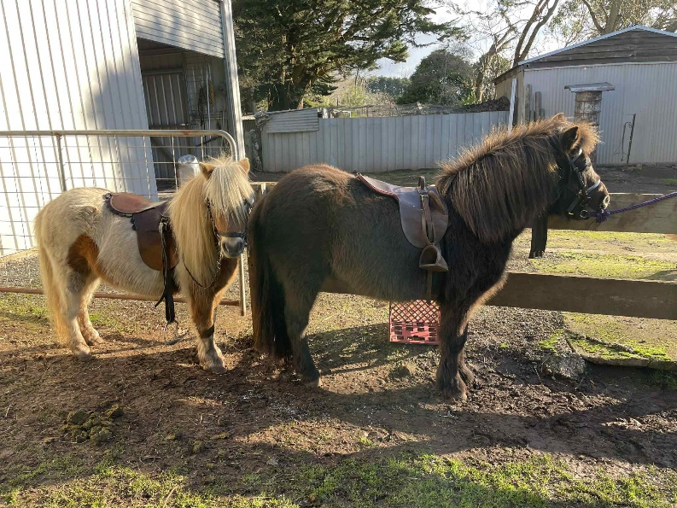
​

🐴 Program Overview
Our Equine Assisted Learning (EAL) program is a goal-focused, experiential learning experience delivered in partnership with our trained horses. Designed specifically to support participants of the National Disability Insurance Scheme (NDIS), this program promotes physical, emotional, and psychosocial development in a safe, inclusive, and empowering environment.
EAL will include lead-led riding in a secure contained paddock. All other equine activities occur on the ground, making it suitable for participants of all mobility levels. At this stage we do not provide riding for those with mobility issues.

🗓 Session Details
- When: Every Sunday
- Duration: 1-hour sessions
- Frequency: Weekly (or as per participant’s plan)
- Group Size: up to 4 participants per timeslot.
- Location: NDIThrive Farm, 231 Bangholme Rd, Bangholme

🎯 NDIS-Aligned Learning Outcomes
Each session is structured to support participant goals under the following domains:
Domain Skills Developed
Social & Community Participation Communication, cooperation, teamwork, respect for others
Health & Wellbeing Mindfulness, emotional regulation, self-awareness
Capacity Building Confidence, responsibility, independence
Sensory Regulation Calming sensory input through equine contact
Daily Living Routine development, task completion, safety awareness
​

🐎 What to Expect in a Session
Each session is led by qualified facilitators with experience in disability support and equine therapy. Activities may include:
- Leading and grooming horses
- Building obstacle courses with horses
- Observation and reflection exercises
- Trust and leadership tasks
- Goal-oriented exercises tailored to individual NDIS plans
All activities are adapted to meet each participant's ability level and personal goals.
Lead Lead Rides - note that not every session will incorporate riding
​👥 Who Can Participate?
- Children (5+) and adults with physical, intellectual, sensory, and/or psychosocial disabilities
- Plan-managed or self-managed NDIS participants
- No prior horse experience necessary

📝 NDIS Billing Information
All our services come out of CORE in the NDIS budget. We can use CB Daily Activity also, however this needs to be a stated support.
​

PERSONAL TRAINING

Wednesday’s Weekly with Time Slots between 10am and 4pm

Personal Training with NDIThrive offers tailored fitness sessions designed to support your unique goals and needs. Whether you’re looking to improve strength, boost energy, or enhance overall wellbeing, our experienced personal trainers will work with you to create a personalised fitness plan. We focus on safe, inclusive exercises that help you build confidence, increase mobility, and achieve your fitness goals at your own pace. At NDIThrive, we’re committed to empowering you to feel stronger and more capable, every step of the way!

Our Story
At NDIThrive, we believe in the transformative power of the mind. Our journey into holistic care began with our own personal experiences – witnessing the profound changes it brought to our lives. Through our large Hippy Spiritual Shops, The Living Earth Co., we saw customers seeking something deeper, and at night, we hosted large Spiritual Groups with Allied Health professionals, Support Workers, and others who recognized the need for more comprehensive care. It became clear to us that there was a gap to be filled, and we knew we had to help bridge it.
By blending our knowledge of nurturing the mind, body, and soul alongside traditional Western medicine, we offer a unique service within the NDIS Disability sector.
At NDIThrive, we are committed to providing a safe, welcoming space for people of all abilities and backgrounds to discover the life-changing benefits of a holistic lifestyle while meeting the goals of the NDIS framework. We believe that everyone deserves the opportunity to heal, grow, and thrive – and we're here to help make that happen.

The Important Stuff
WHAT TO BRING
Participants are required to:
Dress suited to the weather conditions (Hats in Summer/Beanies in Winter for Outdoor Programs)
Clothes suited to: painting, woodworking, gardening, cooking
Bring a water bottle – labelled with name
Any comfort items
Morning and afternoon tea plus lunch provided for full day participants otherwise a packed lunch for workshops and stand alone groups (e.g. Woodwork, Creative Art, Pottery and Equine Assted Learning).
*** Bikkies and Water always available***

PROJECT WORK IN STANDALONE WORKSHOPS
Participants will be involved in a range of projects each term based on their peer group and abilities. These projects are designed to add an additional layer of learning and personal development that will bring a sense of purpose, team work and goal orientated experiences. Participants take home their projects.

BOOKING
To secure your place in our programs, please read the descriptions in this Welcome Pack, and complete the online intake, service agreements, allergies and anaphylactic and NDIS Consent to Share forms via the links below.

MATERIALS
Fees include all program facilitation, materials, and take-home work from the term. Should additional materials be required for a program, these will be communicated with parents upon registration or during the program.

SUPERVISION
Supervision is provided for the entirety of the program each day from 10am - 3pm. We ask that you do not arrive prior to 9.55am and collect your participant by 3pm. Should you be running late for pick up, please contact us as soon as possible by phone.

FEES
NDIThrive adheres to the current NDIS Pricing Arrangements for all supports provided. We have 3 x 15 min components (setup and packdown, and a NF2F fee) to ensure high quality outcomes are achieved, goal setting is observed and report writing is achieved. We charge a 1 hour equivalent Support Charge of $70.23 to cover the food and material costs incurred during our day programs. These charges will appear as 04 Access Community line items for the 15 min setup/packdown fees, and 01 Daily Activities for the Food/Materials charge.
Additional costs will be incurred should the participant require transport or 1:1 support during the programs or Entry Costs to Sites of Interest e.g. Museum or Park Entries. Ratio are generally 1:2 otherwise 1:1 should the support be required.

If you or your participant has a disability or medical condition that requires additional supports or a higher ratio of staff, please contact us prior to booking. All NDIThrive staff are qualified support workers and are able to provide individualised supports including positive behaviour support strategies.

CANCELLATION POLICY
Cancellations more than 7 days prior to program commencement will not incur a fee. There are no refunds for Cancellations within 7 days of each program or individual support commencing.

NDIThrive Schedule of Fees

Please note that all groups are facilitated at a 1:2 ratio (excepting EAL) unless additional support is required and discussed prior to commencement. If additional support is required, additional fees apply based on the current NDIS Pricing Arrangements. We also charge a one-off cost for all new participants entering our farm programs of $702.30. This is covered within the NDIS Plan. The line item is 04 Establishment Fee For Personal Care Participation Group And Centre Based Activities. It is charged after 2 sessions, with the client happy to continue.

Group Farm Day Programs  1:2 ratio  10am – 3.00pm 5hrs (June-August)  10am – 4.00pm 6hrs (Sept-May)  Morning Tea, Lunch, Afternoon Tea Supplied  All activity resources supplied  *Transport Available | $35.12 per hour ($175.60) or ($210.72)  $2.59 ph Centre Capital Cost $12.95/$15.54  $35.12 (Packup/Packdown Fee of 15min each) total 30mins  $17.55 (15 min Report Writing Fee)  $70.23 = 1 hour fee to cover all food, art supplies and materials  Total 1:2: $311.45 (5hrs) / $349.16 (6hrs)  Total 1:1: $487.00 (5hrs) / $559.82 (6hrs)
Woodwork (Friday’s 2-4pm)  1:2 ratio  2.00pm-4.00pm (2hrs)  Light Refreshment Provided  All activity resources supplied  *Transport Available | $35.12 per hour ($70.24)  $2.59 ph Centre Capital Cost (Centre Fee) $5.18  $35.12 (Packup/Packdown Fee of 15min each) total 30mins  $17.55 (15 min Report Writing Fee)  $35.12 = 1/2 hour fee to cover all supplies and materials  Total 1:2: $163.21  Total for 1:1: $233.45
Creative Art (Sunday’s 2-4pm)  1:2 ratio  2pm-4pm (2hrs)  Light Refreshment Provided  All activity resources supplied  *Transport Available | $35.12 per hour ($70.24)  $2.59 ph Centre Capital Cost (Centre Fee) $5.18  $35.12 (Packup/Packdown Fee of 15min each) total 30mins  $17.55 (15 min Report Writing Fee)  $35.12 = 1/2 hour fee to cover all supplies and materials  Total 1:2: $163.21  Total for 1:1: $233.45
Equine Assisted Learning (EAL)  (Sunday’s hourly 11am-1pm)  1:1 ratio  Light Refreshment Provided  All activity resources supplied  *Transport Available | $127.43 for the hour  $2.59 for the hour Centre Capital Cost (Centre Fee)  $17.55 (15 min Report Writing Fee)  Total: $147.57
Transport  Travel Time  Travel Kms | $1.00 per km travelled (with client in vehicle) plus pro rata of hourly rate

NDIThrive Other Services Schedule of Fees

All prices below are based on 1:1 ratio. Where applicable ratio splitting is required, we adhere to the NDIS Pricing Arrangement rules to split the cost between participants
All pricing aligns with the current NDIS Pricing Arrangements and is subject to change.

CORE
Description | Rate per hour
Support Worker Weekday  6.00am – 8.00pm | $70.23
Support Worker Weekday Evening  8.00pm – 12.00am | $77.38
Support Worker Weekday Night  12.00am – 6.00am | $78.81
Support Worker Saturday | $98.83
Support Worker Sunday | $127.43
Support Worker Public Holiday | $156.03
Support Worker sleepover rate 12am – 6pm (Non active) | $297.60
House cleaning support | $58.03
Garden and Home Maintenance support | $56.98
Assistance with Personal Domestic Assistance | $59.06
Capacity Building and training in Self Management and Plan Management | $80.06
STA and assistance (inc. Respite) - 1:1 - Weekday | $2178.57
STA and assistance (inc. Respite) - 1:1 - Saturday | $2785.13
STA and assistance (inc. Respite) - 1:1 - Sunday | $3527.69
STA and assistance (inc. Respite) - 1:1 – Public Holiday | $4270.25
Group Activities Standard – Weekday Daytime | $70.23
Group Activities Standard – Weekday Evening | $77.38
Group Activities Standard – Saturday | $98.83
Group Activities Standard – Sunday | $127.43
Group Activities Standard – Public Holiday | $156.03
Centre Capital Cost | $2.59
Support Workers include: In home, Community Access, personal care supports.
CAPACITY BUILDING SUPPORTS
Life Transition Planning Incl. Mentoring Peer-Support and Indiv. Skill Development | $80.06
Community Participation Activities | Dependent on Activity
Skills Development and Training | $80.06
Individual Social Skills Development | $80.06
Occupational Therapist | $193.99
Speech Therapist | $193.99
Other Allied Health Therapist e.g. play therapist | $193.99
Counsellor | $156.16
Psychosocial Recovery Coaching - Weekday | $105.43
Psychosocial Recovery Coaching – Weekday Evening | $116.16
Psychosocial Recovery Coaching – Weekday Night | $118.31
Psychosocial Recovery Coaching - Saturday | $148.36
Psychosocial Recovery Coaching - Sunday | $191.29
Psychosocial Recovery Coaching – Public Holiday | $234.23
Coordinator of Supports (Level 2) | $100.14
Specialist Support Coordinator (Level 3) | $190.54
Employment Assistance | $70.23

All Costs can be covered within most NDIS Plans

We do not have a lock in contract. We don’t hold funds. We do have a 7 day cancellation notice. We purchase materials and supplies, purchase food and organize programs so it is vital you let us know if you are going to be away, or the full charge will incur.

LINKS FOR JOINING
NDIS Clients
- New Client Intake Form
https://ndithrive.snapforms.com.au/form/ndithrive-new-client-intake-form

- Service Agreement:
https://ndithrive.snapforms.com.au/form/ndithrive-ndis-service-agreement

- NDIS Consent for Your Information
https://ndithrive.snapforms.com.au/form/ndithrive-consent-for-your-ndis-information

- Allergies & Anaphylactic Form
https://ndithrive.snapforms.com.au/form/ndithrive-allergies-asthma-and-anaphylaxis-form

We need you to fill in ALL forms before we can onboard you. We ask for a copy of your NDIS plan to ensure you have funds to access our programs with continuity, to help you through different funding options within your plan (we can draw from many budgets), and work with your Care Team on the same page to help you navigate the NDIS. Please fill in as much details as possible about yourself so we can make sure your experience is a awesome one!

