NDITHRIVE CLIENT WELCOME PACK
Welcome to NDIThrive Pty Ltd.
We are thrilled you have reached out to join us.
Read through the information provided on what we offer and give us a call if you have any further questions.
At NDIThrive, we are a compassionate partner in nurturing and developing your independence, growth, and wellbeing. It's what our name stands for.
Our mission is rooted in the belief that every individual deserves personalised care, enabling them to truly THRIVE. Whether you're seeking a nurturing space for personal growth, in-home supports or a meaningful, engaging program on a real working farm, NDIThrive is here to support you every step of the way.

Our Day Programs are available for ages 8 – Adult that have an NDIS Plan.
Our ASDAN Internationally Accredited Courses are for everyone however we are not Government Funded. You can pay through your NDIS Plan if you are a participant, through your School if they have Disability Inclusion Funding, or privately.
PLEASE NOTE: WE ARE RELOCATING TO PEARCEDALE EARLY NEXT YEAR 2027 where we will have a purpose built Art/Cooking Centre and multiple Nursery areas for Horticulture. It will be from here that our ASDAN Programs will Commence in Term 1 2027 (First week of February)
** At the end of this form – there are links to our NDIS Intake and NDIS Service Agreement Forms for you to fill out. They are all able to be done online (no printing or scanning)

Our Supports offer personalised care that are tailored in design to meet the unique needs and goals of each participant.

NDIThrive offers supports including;
​Individual Support including in-home/community/shopping/Dr’s and transport
Counselling & Psychosocial Recovery Coaching including Group Workshops
Therapies
Farm Day Programs (Kids and Adults)
Skill Development through our Wednesday Life Skills Program (Retiring in 2027) to make way for our
ASDAN Internationally recognised Certificate Courses
Together, let's cultivate a future full of independence and infinite possibilities.

OUR PURPOSE
At NDIThrive, we believe every person deserves the chance to grow, connect, and thrive in an environment built on trust, nature, and genuine care. Through our farm-based programs, we empower individuals of all abilities to build real-world skills, form meaningful relationships, and discover their own capacity for independence — one day, one animal, one small victory at a time.
We are committed to creating a place where dignity of risk is respected, where every person's goals guide the support we provide, and where the rhythm of farm life — caring for animals, tending the land, working alongside others — becomes a pathway to confidence, connection, and lifelong capability.
MISSION
At NDIThrive, our mission is to create a nurturing and empowering environment where individuals can grow, heal, and achieve independence. Through personalised care, we aim to inspire connection, well-being, and a sense of purpose, enabling everyone to truly thrive.
VISION
Our vision at NDIThrive is to be a leading provider of innovative, therapeutic care, where every individual feels empowered to reach their full potential. We strive to create a world where connection with self, empowerment and community, fosters lasting independence, resilience, and well-being.
THRIVE Values
T – Trust | H – Honesty | R – Respect | I - Individuality | V – Values | E - Empowerment

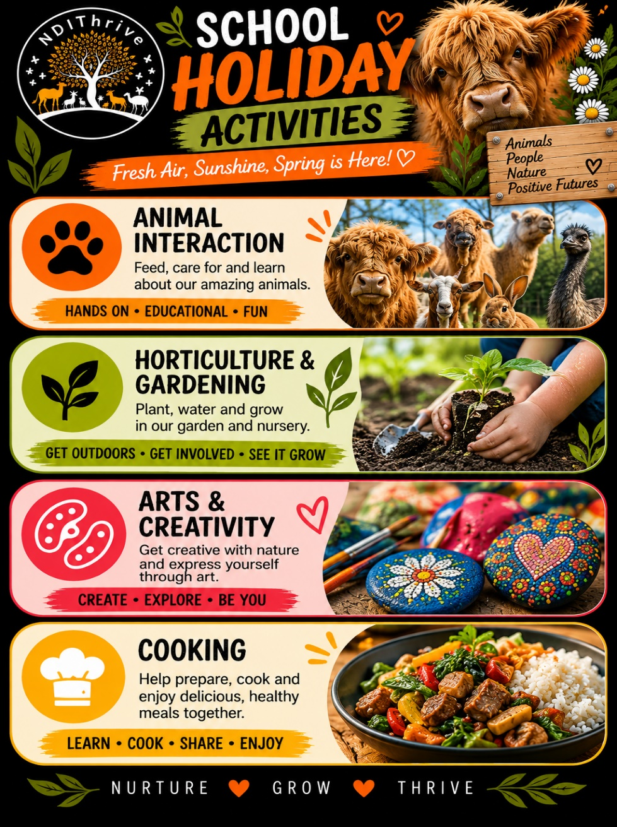
WHAT WE OFFER
FARM DAY PROGRAMS/SCHOOL HOLIDAY PROGRAM
NDIThrive Program Outline

Location: 231 Bangholme Road, Bangholme VIC 3175 (From January 2027 – 110 South Boundary Rd East, Pearcedale VIC 3912)
Schedule: Monday’s, Tuesday (fortnight) and Wednesdays we have kids aged 8-17. Adults all week however Adults Groups on Wednesday, Thursday and Fridays. We can support Kids and Adults 1:1 anytime when we have capacity.
Program Duration: 9am-4pm
Participants: Participants on the NDIS
Funding: 04 - Core line items or Capacity Building

Farm Daily Program Structure

(for School Holiday Program Also)

Arrival and Registration

Participants arrive, check-in, and handover to Support Workers/ Facilitators for the day.

Provided: Farm Day Programs NDIThrive provide Morning/Afternoon Tea, and a cooked Lunch.

Please bring any personal water bottles, however water bottles will also be available.
Some Days will be In-House. Most in-house days will be weather determined. (See below alternate program).
Our Farm offers a diverse range of activities such as Animal Husbandry, Garden and Horticulture, Cooking, Crafting and Fresh Air. There is much to do on our Farm and no two days are the same however we believe in allowing people to breath, relax and connect with their surroundings also. Clients engage and regulate through nature based activities and our holistic approach to connection with land and self, we have found helps center and regulate emotional disengagement.

Learning Outcomes: Self-Awareness and Self-Advocacy | Resilience Building | Personalized Goal Setting | Community Engagement and Social Connection | Emotional Regulation and Wellbeing | Empowered Decision-Making | Independence and Self-Sufficiency | Adaptability and Growth Mindset | Collaborative Teamwork

Lunch Breaks
FARM DAY PROGRAMS: Participants source ingredients from the farm or provided by NDIThrive and with guided assistance, prepare a nutritional lunch which is then enjoyed communally. They can also just watch and be fed yummy food if they do not wish to participate!
Examples of lunches day programs might be cooking using ingredients grown from the farm to make pizza’s, taco’s, stir fry’s, roasts, or zucchini slice for example. We love using our own eggs to make cakes, scones, quiche’s and omelets. NDIThrive Staff hold Food Handling Certificates. We also have EPIPENS for Adults and Children and stay aware of provided information regarding Allergies and Intolerances.

4:00 PM: Program Conclusion and Departure

Participants prepare to leave.

Staff provide feedback and discuss the day's achievements with participants and caregivers.

IN-HOUSE PROGRAM (FOR WET or HOT WEATHER DAYS):
Overview:
On wet or extremely hot weather days, in-house programs in our Art Centre offer a fun and relaxing environment where individuals can explore their creativity through hands-on projects and enjoy games. These activities are designed to foster self-expression, relaxation, and social connection.

1. Creative Project Activities
- Collages
  - Activity: Participants create collages reflecting their interests, emotions, or imaginative designs.
  - Goal: Encourage creativity and self-expression.
- Painting
  - Activity: Individuals paint free-form art and group pieces, themed pieces, or explore new painting techniques.
  - Goal: Promote creativity, relaxation, and visual communication in a group.
- Crafting
  - Activity: Crafting projects like jewelry, cards, or decorations using nature such as pinecones, tree bark and rocks.
  - Goal: Develop fine motor skills and artistic creativity.
- ClayWorks/Pottery
  - Activity: Individuals explore clay and how to mould and shape making unique pieces. We may use the Pottery Wheels however we don’t do large pieces. Clients are able to prepare and fire (Staff to use Kilns) smaller pieces. Pottery may not be offered every day.
  - Goal: Promote creativity, relaxation, and visual communication in a group while exploring the medium of clay.
- Stenciling
  - Activity: Use stencils to create patterns on canvas and other mediums.
  - Goal: Encourage precision and fine motor skills.

2. Games & Group Activities
- Board Games
  - Materials: A variety of board games.
  - Activity: Play fun and interactive games that encourage teamwork or friendly competition.
  - Goal: Foster socialization, strategic thinking, and relaxation.
- Puzzle Challenges
  - Materials: Jigsaw puzzles, brainteasers.
  - Activity: Work individually or in teams to complete puzzles or solve challenges.
  - Goal: Enhance problem-solving skills and teamwork.
- Indoor Scavenger Hunt
  - Materials: A list of items to find, small rewards.
  - Activity: A fun search for hidden items around the indoor space.
  - Goal: Develop observation skills and teamwork.

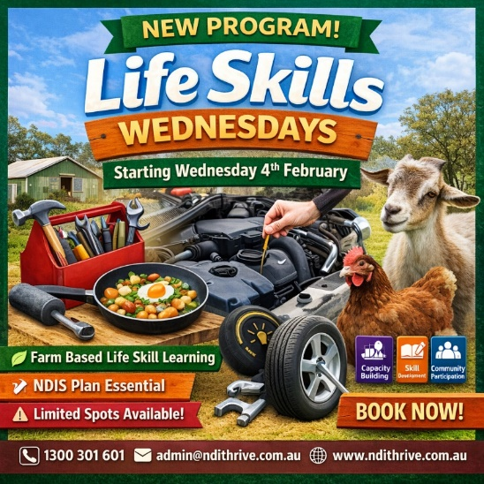
Life Skills Wednesdays
(Please note this will be replaced with ASDAN Accreditation Programs in 2027)
Skill Development & Training Program
Day: Wednesday
Time: 10:00am – 3:00pm
Location: NDIThrive Farm
NDIS Line Item: Capacity Building – Skill Development and Training incl Public Transport Training
Catering: Morning tea, lunch, and afternoon tea included

Program Overview
Life Skills Wednesdays is a practical, hands-on skill development program delivered on NDIThrive’s Farm. The program supports participants to build essential everyday life skills while engaging in meaningful farm-based activities.
Skills are introduced in a basic, accessible format and are developed and built upon over time, allowing participants to gain confidence, competence, and independence at their own pace.
The farm environment provides natural opportunities for animal interaction, routine building, responsibility, and practical learning, creating real-world, transferable outcomes.

Core Skill Areas
1. Basic Tool Identification & Safe Usage
Participants will learn:
- Identifying common household and farm tools (e.g. screwdrivers, hammers, pliers, Allen keys)
- Understanding what each tool is used for
- Safe handling and basic tool safety rules
- Correct storage and care of tools
- Supervised practice through simple tasks

2. Basic Cooking Skills
Participants will develop foundational kitchen skills, including:
- Kitchen safety and hygiene
- Identifying kitchen tools and equipment
- Simple food preparation (washing, chopping, measuring)
- Safe use of basic appliances (where appropriate)
- Preparing simple meals and snacks
- Cleaning, packing away, and food storage basics

3. Basic Home Handyperson Skills
Participants will learn everyday home maintenance skills such as:
- Identifying different types of light bulbs
- Safely changing a light bulb
- Basic electrical safety awareness
- Understanding washers and why taps drip
- Identifying basic plumbing tools
- Practising simple, non-invasive maintenance tasks

4. Farm-Based Life Skills and Animal Husbandry
The farm setting forms a key part of Life Skills Wednesdays. Participants will:
- Engage in supervised animal interactions
- Learn daily animal care routines
- Participate in basic animal husbandry tasks such as feeding, cleaning, and monitoring wellbeing
- Learn responsibility, consistency, and routine
- Develop empathy, respect, and safety awareness around animals
- Support light farm maintenance related to animal care
Animal interaction is used intentionally to support emotional regulation, confidence building, and practical skill development.

5. Motor Vehicle Familiarisation & Basic Maintenance Awareness
Participants will be introduced to essential motor vehicle knowledge to support independence and safety. Learning includes:
- Identifying key parts of a vehicle under the bonnet
- Understanding where engine oil goes and how to check oil levels
- Identifying coolant/water reservoirs
- Understanding windscreen washer fluid and how to refill it
- Recognising windscreen wipers and their purpose
- Understanding fuel basics, including different fuel types and which vehicles require each
- Learning basic tyre safety and awareness
- Understanding the steps involved in changing a tyre (demonstration and discussion)
- Knowing when a task can be attempted and when professional help is required
- All vehicle-related learning is delivered safely and appropriately, focusing on knowledge, awareness, and confidence rather than mechanical complexity.

6. Everyday Household & Independence Skills
Additional life skills are introduced gradually, including:
- Understanding household systems and safety
- Following instructions and routines
- Building problem-solving skills
- Knowing when to seek assistance
- Developing confidence in managing everyday responsibilities

Program Structure
- Hands-on, experiential learning in a farm environment
- Small group delivery with individualised support
- Skills broken down into manageable steps
- Repetition and progression over time
- Supports tailored to participant goals, abilities, and interests

Outcomes
Participants will:
- Build independence in daily living skills
- Gain confidence with tools, cooking, and home tasks
- Develop responsibility through animal care
- Increase understanding of vehicle safety and maintenance basics
- Strengthen problem-solving, safety awareness, and self-confidence
- Gain practical, transferable life skills for home and community living
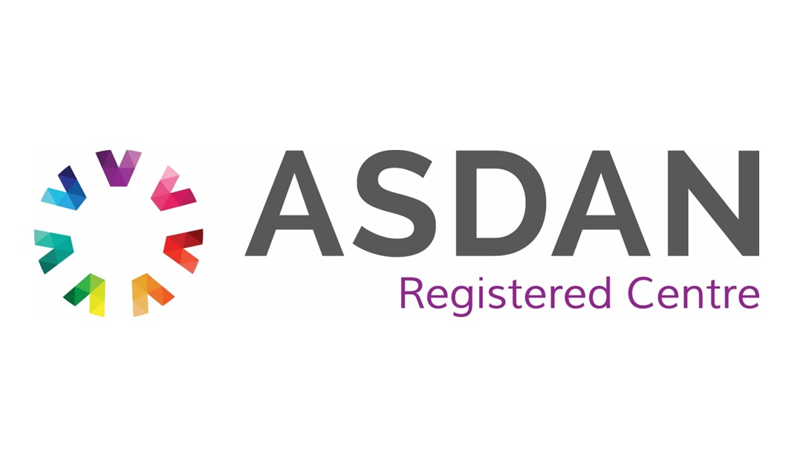
ASDAN Program Catalogue — Short Courses & Pathway Programs
NDIThrive Pty Ltd is approved to deliver ASDAN's full Short Course catalogue. Each Short Course is a flexible, portfolio-based program accrediting 10–60 hours of activity, and can stand alone as a single term's study or be combined with other Short Courses before certification. Courses are internally moderated and evidenced through a student portfolio (or e-portfolio), built up as learners complete practical challenges.

Personal & Social Development
PSHE — Covers personal, social, health and economic topics such as keeping safe and healthy, financial choices, and respectful relationships — modules can be tailored to each learner's needs and understanding.
Citizenship — Builds understanding of citizenship issues, rights, responsibilities and participating in society, aligned to key citizenship topics.
Beliefs and Values — Helps learners explore different beliefs and value systems, understand diverse perspectives, and develop the social skills to engage with a multicultural community.
Personal Finance — Builds financial awareness and money-management skills, aimed at increasing learners' economic wellbeing and confidence handling their own finances.
Living Independently — Focused on the practical and personal skills needed for independent living — budgeting, home management, and self-care routines.

Careers, Enterprise & Leadership
Careers and Experiencing Work — Supports careers education and work-experience planning — helping learners explore career options, build employability skills, and plan next steps into further education, apprenticeships, or work.
Enterprise — Develops enterprise and entrepreneurial skills through practical activity-based challenges.
Leadership — Builds leadership skills and confidence — suitable both for learners new to leadership and those wanting to formalise existing leadership experience.
Employability Skills Development — A broader skills-development pathway (sits alongside the Short Courses) focused on the practical skills needed to enter and succeed in the workplace.
Peer Mentoring — Recognises learners who are developing and practising mentoring or 'buddying' skills in supporting others.
Activities and Peer Tutoring — Accredits general mixed activity, particularly suited to informal or community settings — plus a peer-tutoring award for learners supporting others through their activities.
Volunteering — Recognises and accredits volunteering activity and the skills developed through it.
Volunteering as an Adult — The adult-oriented equivalent of the Volunteering course, designed for adult volunteers (for example, workplace volunteering schemes or ongoing charity work).
Practical & Life Skills
Gardening — Builds practical horticultural skills through hands-on gardening activity, alongside personal, social and work-related skills.
FoodWise — Develops cooking and food-preparation skills, healthy eating knowledge, budgeting around food, and understanding of the food industry.
Animal Care — Accredits involvement in caring for animals — anything from domestic pets to farm animals — building practical animal husbandry and responsibility skills.
Environmental — Builds awareness and understanding of environmental issues through hands-on projects and activities, developed in partnership with Eco-Schools.

Sport, Activity & Creative
Sports and Fitness — Accredits involvement in sport and fitness activity across any combination of pursuits, from team sports to swimming to individual fitness training.
Football — A football-specific version of the sport and activity Short Courses, accrediting participation and skills development through the game.
Esports — Accredits skills development through competitive/organised gaming activity.
Expressive Arts — Covers all forms of creative expression — visual art, performing arts, music, craft and writing — building practical arts skills and creative confidence.
Adventure and Residential — Accredits out-of-centre activity such as outdoor/adventure trips, residentials, museum and gallery visits, or field trips.

Curriculum Subjects
English — Supports English language and literacy skills development through structured, evidenced activity.
Mathematics — Supports numeracy and maths skills development through structured, evidenced activity.
Science — Supports science knowledge and skills development through structured, evidenced activity.
Geography — Supports geography knowledge and skills development through structured, evidenced activity.
History — Supports history knowledge and skills development through structured, evidenced activity.
Languages — Supports language-learning skills development through structured, evidenced activity.
Note
ASDAN is withdrawing the RoadWise Short Course and its Vocational Taster titles (Computing, Construction, Hair and Beauty, Hospitality, Land-based Sector, Manufacturing, Uniformed Services). Registrations close 31 December 2026, with a final certification date of 31 August 2027 — these are not included above as they won't be available for new enrolments going forward.

Longer Pathway Programs (beyond Short Courses)
These are accredited curriculum programs, not regulated qualifications - evidenced through a portfolio, journal or learner record and signed off through internal/external moderation, rather than examined. They're designed to be built up over multiple terms and give a more substantial, cumulative certificate at completion.
Personal Development Programmes (PDP) — ASDAN's longstanding flagship program, covering 12 broad modules (communication, community, independent living, health & wellbeing, world of work, expressive arts, and more). Learners build a portfolio of evidence and progress through Bronze, Silver and Gold awards based on hours completed.
Preparing for Adulthood - New Horizons — An activity-based curriculum supporting PSHE, citizenship and careers education, typically used as an earlier-stage program before moving into the other Preparing for Adulthood pathways.
Preparing for Adulthood - Transition Challenge — Builds independent living and personal skills, with content linked to core subject areas - offered at different levels depending on learner needs.
Preparing for Adulthood - Towards Independence — A flexible, modular program (80+ modules) offering formal recognition for small, individual steps of achievement - covering communication, numeracy, independent living, community participation, and work-related skills. Modules can be selected and combined to suit the learner.
Preparing for Adulthood - Workright — Focused specifically on developing transferable employability skills, suited to learners on a work-related or work-experience pathway.
My Independence - Exploring Aspirations — Supports PSHE, citizenship and careers education, built around the four Preparing for Adulthood pathways (employment, independent living, good health, friends/relationships/community).
My Independence - Transforming Aspirations — Covers core subject areas through the same four Preparing for Adulthood pathways, with content that can be mapped to individual outcome plans.
My Independence - Realising Aspirations — A more advanced, person-centred program built around the same four pathways - modules can be combined flexibly to meet individual needs and goals.
My Independence - Supporting Aspirations — The most flexible of the four, designed to be combined with Realising Aspirations modules to meet individual needs.
Moving On — A practical, journal-based program (not portfolio-evidenced) supporting young people and adults preparing to live independently for the first time - covering things like budgeting, bills, and managing a household. Completion is signed off by a trusted adult/support person rather than through formal moderation.
Employability Skills Development — An activity-based program building awareness of employer expectations and workplace skills - self-management, teamwork, communication, applying for jobs, and workplace health & safety. Non-regulated.
Lifeskills Challenge — An online bank of customisable challenges spanning pre-Entry through to Level 3, mapped to the four Preparing for Adulthood pathways and covering areas like English, maths and PSHE - allows a highly personalised curriculum for individual learners.

Enrolments now open
Limited places available.
📞 1300 301 601
📧 admin@ndithrive.com.au

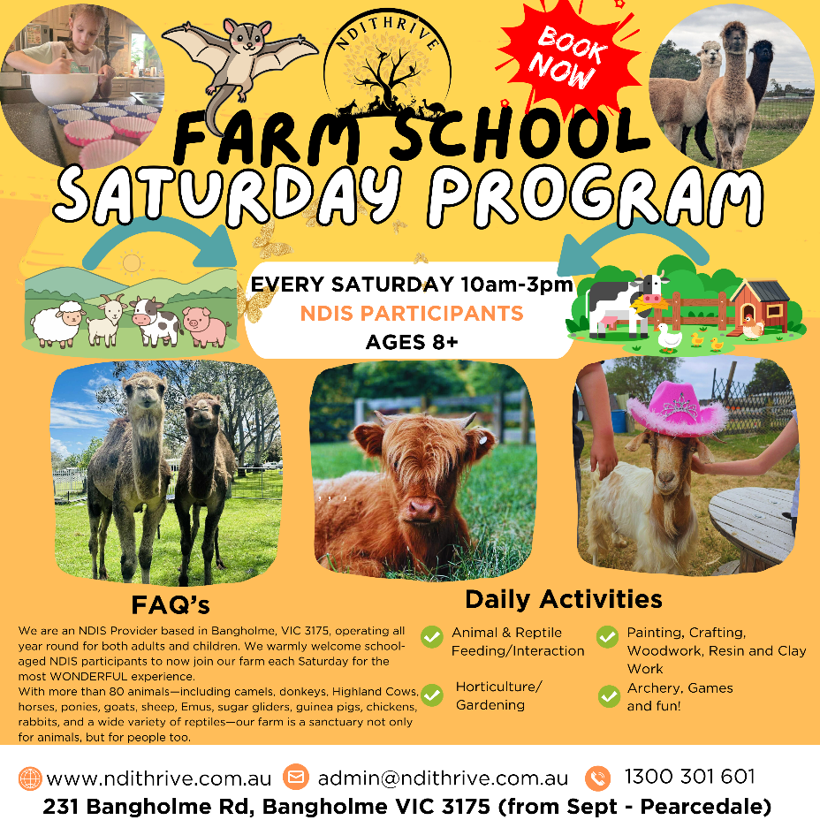
SATURDAY FARM DAY PROGRAM
10AM-3PM
🌿 NEW Saturday Farm Day Program – Now Open! 🐑🐐
​
We’re excited to introduce our Saturday Farm Day Program at NDIThrive – a unique, hands-on experience designed exclusively for NDIS participants.
Each week includes:
🐾 Animal interaction (including reptiles + feeding time!)
🌱 Horticulture, gardening, seed propagation & harvesting
🍳 Cooking session with a shared lunch
🎨 Arts & crafts – woodwork, resin, clay, bead work & nature-based creations

This is fast becoming one of the most unique programs in the area, and places are already filling quickly from our waitlist.

⚠️ Don’t wait for school holidays – join us every Saturday and be part of something special!


ANXIETY AND STRESS MANAGEMENT WORKSHOP (Adults)
Our Anxiety and Stress Management Workshops are designed to support participants in understanding, managing, and responding to stress and anxiety in a safe, supportive group setting.
​
Across this program, participants will learn practical tools to recognise stress responses, understand how anxiety shows up in the body, and develop effective strategies to regulate emotions and respond to triggers.
The workshops focus on building self-awareness, emotional regulation, and confidence — both within the sessions and out in the community.
Participants will be supported to:
- Recognise stress and anxiety responses in the body
- Learn grounding and regulation strategies
- Build confidence in managing triggers and stressors
- Strengthen communication around needs and boundaries
- Develop a sense of internal safety and self-trust
- Apply skills in real-world and community settings

The overall goal of the program is to help participants feel safe enough within themselves to create personal safety systems, recognise what safety feels like, and respond effectively when faced with challenging situations.

This program is expected to continuously, meeting weekly on a Tuesday at 4pm for 1hour.


INDIVIDUAL SUPPORTS

Individual NDIS Supports at NDIThrive
At NDIThrive, we are dedicated to providing personalised NDIS support that empowers individuals to achieve their goals and enhance their quality of life. Our approach focuses on a holistic, person-centered model of care, offering tailored services that address the unique needs and aspirations of each participant.

Key Features of Our Individual NDIS Support:
- Personalised Care Plans: We work closely with participants to develop individualised support plans that are focused on achieving specific goals, whether it’s improving communication, increasing independence, or enhancing social participation.
- Skill Development: Our support services focus on building important life skills, including communication, personal care, social interactions, and decision-making. We offer programs in areas such as creative arts, community engagement, and daily living skills.
- Assistance with Daily Activities: We provide hands-on support for daily tasks, including personal care, household chores, and managing appointments, helping participants maintain their independence and lead fulfilling lives.
- Capacity Building: Through tailored activities and interventions, we help individuals build skills for long-term independence, such as financial management, travel training, and accessing community resources.
- Community and Social Participation: We encourage individuals to engage with their local communities through social, recreational, and educational activities, fostering greater social inclusion and community connection.
At NDIThrive, our goal is to support each individual in reaching their full potential by providing the care, guidance, and resources needed to thrive in all aspects of life.



COUNSELLING
Counselling
We offer counselling to provide a holistic approach to wellbeing.
Our counselling offers a safe, supportive space to explore challenges, process emotions, and build strategies for personal growth..
We support both the inner journey of healing and resilience, and the practical journey of rebuilding and thriving in everyday life. This integrated approach ensures you have the emotional guidance and hands-on support needed to create lasting change and greater quality of life.


SYNERGY PLAY THERAPY
Synergy Play Therapy at NDIThrive
At NDIThrive, we offer Synergy Play Therapy, a therapeutic approach designed to support children and individuals (even adults!) in overcoming emotional, behavioral, and developmental challenges through the power of play. Our Play Therapy services are grounded in creating a safe, nurturing environment where participants can express themselves, process emotions, and build coping skills in a creative and engaging way.
Key Features of Synergy Play Therapy:
- Individualised Therapy Sessions: Our Play Therapist provides one-on-one sessions tailored to each participant’s unique needs, using a variety of play-based techniques to address emotional, social, and psychological challenges.
- Emotional Expression and Processing: Play therapy allows participants to express and explore their feelings in a non-threatening, enjoyable way. Through activities like role-play, storytelling, and art, children and individuals can process emotions they may struggle to verbalise.
- Building Social and Communication Skills: Play Therapy fosters the development of important social skills, such as sharing, turn-taking, and communication. It also provides a supportive environment for participants to build self-esteem and improve relationships with others.
- Behavioral Support and Development: Our therapy approach helps participants understand and manage their behaviors, with a focus on building positive coping strategies and emotional regulation skills.
- Trauma-Informed Care: For individuals who have experienced trauma or challenging life experiences, Synergy Play Therapy provides a gentle, supportive space for healing. Therapeutic play can help children and individuals process past experiences and work through fears, anxiety, or grief.
- Goal-Oriented Progress: We work collaboratively with families and other support teams to set achievable goals and track progress. The therapeutic activities are designed to build skills and create lasting positive changes in emotional and social development.
- Holistic Approach: Synergy Play Therapy integrates different therapeutic techniques, including expressive arts, sensory activities, and games, to support the mental, emotional, and physical well-being of each participant.
- Family Involvement and Support: We encourage family members to be involved in the therapeutic process, providing guidance on how to support their loved one’s growth and development at home.
At NDIThrive, Synergy Play Therapy helps individuals build resilience, emotional intelligence, and the skills needed to navigate challenges. Our goal is to provide a nurturing, therapeutic environment where individuals can thrive emotionally, socially, and behaviorally, ultimately empowering them to lead more fulfilling lives.

Our Story
NDIThrive was born from a deep desire to bridge the gap between genuine human connection and the growing need for holistic, values-based support in the disability sector.
For over 20 years, we—Simon and I (married 30 years, 6 children, 6 grandchildren) —have poured our hearts into creating spaces that nurture growth, healing, and authenticity. From our humble beginnings of running some of the largest Homeschooling Groups in New Zealand then on the Mornington Peninsula, to owning and operating our Hippie shops in Frankston and Karingal (The Living Earth Co. now closed) to launching large-scale spiritual groups in our Wellness centre at the rear of the Frankston shop, our days and nights were filled with meaningful conversations and powerful transformations. We travelled extensively, striving to be the change we wanted to see.
During business hours, customers—often NDIS participants—would walk through our doors, drawn to the energy of the store and the healing modalities we embraced. By night, our spiritual gatherings welcomed key workers, psychologists, and allied health professionals—many of whom were all asking the same question: Where is the service that brings it all together?
That question became our call to action.
While our professional background wasn’t in disability, our life’s work has always been in helping people. From global Free Trade Agreements to grassroots community support, we’ve always believed in being the change we wish to see—and NDIThrive was the natural next step.
We had spent 25 years Homeschooling, with 6 children of our own (5 with diagnoses) so knew we had at least "lived" experience.
​With a passionate and highly qualified team beside we’ve embraced the journey of learning and evolving within the NDIS space. What we may have lacked in traditional experience, we’ve made up for with vision, compassion, and a commitment to integrity. Having amazing people around you helps enormously too!
At NDIThrive, we stay true to the values that inspired us from the very beginning: connection, growth, and making a real difference in people’s lives. In July we became an Internationally recognised provider of Accredited Certification pathway programs for NDIS participants and Secondary School students looking for pathways to matriculate. We have just completed NDIS registration and by the end of the year, hope to be a provider of choice not just for NDIS clients, but for SLES Students too.
​The Important Stuff
WHAT TO BRING
Participants are required to:
Dress suited to the weather conditions (Hats in Summer/Beanies in Winter for Outdoor Programs)
Clothes suited to: painting, woodworking, gardening, cooking
Bring a water bottle – labelled with name
Any comfort items
Morning and afternoon tea plus a cooked lunch provided for all full day participants otherwise bikkies and water also available.
BOOKING
To secure your place in our programs, please read the descriptions in this Welcome Pack, and complete the online intake, service agreements, allergies and anaphylactic and NDIS Consent to Share forms via the links below.
MATERIALS
Fees include all program facilitation, materials, and take-home work from the term. Should additional materials be required for a program, these will be communicated with parents upon registration or during the program.

SUPERVISION
Supervision is provided for the entirety of the program each day from 9am-4pm. We ask that you do not arrive prior to 8.55am and collect your participant by 4pm. Should you be running late for pick up, please contact us as soon as possible by phone. Past 4pm, you will be charged in 15 min increments.

FEES
NDIThrive adheres to the current NDIS Pricing Arrangements for all supports provided.
Additional costs will be incurred should the participant require transport or 1:1 support during the programs or Entry Costs to Sites of Interest e.g. Museum or Park Entries. Ratio are generally 1:2 otherwise 1:1 should the support be required.

If you or your participant has a disability or medical condition that requires additional supports or a higher ratio of staff, please contact us prior to booking. All NDIThrive staff are qualified support workers and are able to provide individualised supports including positive behaviour support strategies.

CANCELLATION POLICY
Cancellations more than 7 days prior to program commencement will not incur a fee. There are no refunds for Cancellations within 7 days of each program or individual support commencing or cancellations within shift.

NDIThrive Schedule of Fees
Please note that all weekday groups are facilitated at a 1:2 ratio, Saturday Farm Program at a 1:3 ratio unless additional support is required and discussed prior to commencement. If additional support is required, additional fees apply based on the current NDIS Pricing Arrangements.
In line with the NDIS Price Guide, increases/decreases are reflected on the 1st July of each year.

Group Farm Day Programs & School Holiday Farm Day Program WEEKDAY (Adults and Kids)  9am – 4pm  Morning Tea, Lunch, Afternoon Tea Supplied  All activity resources supplied  Line Item: Core 04 or 15 Skill Development | $36.79 per hour ($257.53)  $18.97 Centre Capital Cost for the day  $128.77 – NF2F  Total 1:2 (7hrs): $405.27  Total 1:1 (7hrs) : $662.8
Group Farm Day Program SATURDAY  Kids aged 8+  10am – 3pm  Morning Tea, Lunch, Afternoon Tea Supplied  All activity resources supplied  Line Item: Core 04 or Skill Development | $34.51 per hour ($172.56)  $13.55 Centre Capital Cost for the day  $181.195 – NF2F  Total 1:3 (5hrs): $367.30
Life Skills Wednesday (Core or Therapy Budget) – All ASDAN Programs  10am – 3pm  Morning Tea, Lunch, Afternoon Tea Supplied  Line Item: Core or 15 Skill Development or  CB Increased Social and Community Part | $36.79 per hour for 5 hours ($183.95) @ 1:2  $13.55 Centre Capital Cost for the day  $128.76 – NF2F  Total (5hrs) : $326.26
Anxiety and Stress Management Group Workshop (Counselling or Core)  Tuesdays 4pm-5pm  Refreshments provided  Line Item: Assessment Recommendation Therapy or Training – Counsellor | $156.16 - 1 hour counselling  $39.04 - NF2F fee  $2.71 - Centre Capital Cost  Total: $197.91
Transport *  Travel Time  Travel Kms | $1.00 per km travelled (with client in vehicle) plus pro rata of hourly rate
Mind, Body and Soul Experience *  Wednesdays  Water available  Line Item: Mind/Body: Assess Training Recommend Therapy or Training – Other  Soul = Core 04 or 01 | $156.16 x 2hrs (Mind and Body)  $73.58 1 hr Soul  $8.13 = 3hrs Center Capital Cost  $35.10 2 x 15min NF2F  Total: $451.46

NDIThrive Other Services Schedule of Fees

All prices below are based on 1:1 ratio. Where applicable ratio splitting is required, we adhere to the NDIS Pricing Arrangement rules to split the cost between participants
All pricing aligns with the current NDIS Pricing Arrangements and is subject to change.

CORE
Description | Rate per hour
Support Worker Weekday  6.00am – 8.00pm | $73.58
Support Worker Weekday Evening  8.00pm – 12.00am | $81.07
Support Worker Weekday Night  12.00am – 6.00am | $82.57
Support Worker Saturday | $103.54
Support Worker Sunday | $133.50
Support Worker Public Holiday | $163.46
Support Worker sleepover rate 12am – 6pm (Non active) | $311.79
House cleaning support | $60.10
Garden and Home Maintenance support | $59.01
Assistance with Personal Domestic Assistance | $61.16
Capacity Building and training in Self Management and Plan Management | $83.87
STA and assistance (inc. Respite) - 1:1 – Weekday | $2178.57
STA and assistance (inc. Respite) - 1:1 – Saturday | $2785.13
STA and assistance (inc. Respite) - 1:1 – Sunday | $3527.69
STA and assistance (inc. Respite) - 1:1 – Public Holiday | $4270.25
Group Activities Standard – Weekday Daytime | $73.58
Group Activities Standard – Weekday Evening | $81.07
Group Activities Standard – Saturday | $103.54
Group Activities Standard – Sunday | $133.50
Group Activities Standard – Public Holiday | $163.46
Centre Capital Cost | $2.71
Support Workers include: In home, Community Access, personal care supports.
CAPACITY BUILDING SUPPORTS
Life Transition Planning Incl. Mentoring Peer-Support and Indiv. Skill Development | $83.87
Community Participation Activities | Dependent on Activity
Skills Development and Training | $83.87
Individual Social Skills Development | $83.87
Occupational Therapist | $193.99
Speech Therapist | $193.99
Other Allied Health Therapist e.g. play therapist | $156.16
Counsellor | $156.16
Psychosocial Recovery Coaching - Weekday | $110.44
Psychosocial Recovery Coaching – Weekday Evening | $121.86
Psychosocial Recovery Coaching – Weekday Night | $123.93
Psychosocial Recovery Coaching - Saturday | $155.41
Psychosocial Recovery Coaching - Sunday | $200.39
Psychosocial Recovery Coaching – Public Holiday | $245.36
Coordinator of Supports (Level 2) * | $100.14
Specialist Support Coordinator (Level 3) * | $190.54
Employment Assistance | $83.87

All Costs can be covered within most NDIS Plans
We do not have a lock in contract. We don’t hold funds. We do have a 7 day cancellation notice. We purchase materials and supplies, purchase food and organize programs so it is vital you let us know if you are going to be away, or the full charge will incur.

IMPORTANT NOTE AROUND BEHAVIOURAL ISSUES

At our farm, our role is to facilitate programs that provide a safe, supported, and welcoming environment for everyone to share. We are not behaviour specialists, and we do not provide behaviour therapy or intervention.
Because animal safety and wellbeing are our highest priority, we cannot allow behaviours such as grabbing, hitting, or hurting the animals. If a participant presents with behaviours of concern, we ask that these are supported and addressed with the guidance of their therapist, occupational therapist, or behaviour support specialist before or alongside their time at the farm.
Our commitment is to ensure both participants and animals can enjoy a positive and safe experience together.

LINKS FOR JOINING
NDIS Clients
- New Client Intake Form
https://ndithrive.snapforms.com.au/form/ndithrive-new-client-intake-form

- Service Agreement:
https://ndithrive.snapforms.com.au/form/ndithrive-ndis-service-agreement

- NDIS Consent to Share
https://ndithrive.snapforms.com.au/form/ndis-consent-to-share-your-information-form

- Allergies & Anaphylactic Form
https://ndithrive.snapforms.com.au/form/ndithrive-allergies-asthma-and-anaphylaxis-form

We need you to fill in ALL forms before we can onboard you. We ask for a copy of your NDIS plan to ensure you have funds to access our programs with continuity, to help you through different funding options within your plan (we can draw from many budgets), and work with your Care Team on the same page to help you navigate the NDIS. Please fill in as much details as possible about yourself so we can make sure your experience is an awesome one!

